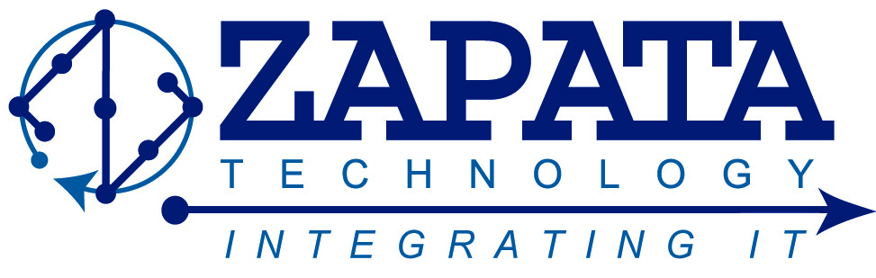
FOR IMMEDIATE RELEASE:
ZAPATA TECHNOLOGY, INC. TO OFFER POSITIONS IN MARYLAND AND GEORGIA
Augusta, GA, November 4, 2013 – Zapata Technology, Inc. (ZAPATA) is pleased to announce the availability of new positions at Aberdeen Proving Ground in Aberdeen, MD. Positions available include programmer/analyst, test analyst, and web developer. In addition, Zapata seeks for its Augusta, GA office an outside sales person, government contracts reviewer, accounting assistant, as well as administrative assistants.
Founded in 2007, Zapata Technology is a HUBZone certified, veteran-owned, and self-certified Small Disadvantaged Business (SDB) IT consulting company. Our incredible team promotes and aggressively facilitates the cost effective integration of technology (products and specialized services) to enhance organizational performance in the areas of; emerging technologies, information technology, and intelligence and cyber solutions. Our employees are dedicated, ethical, hold the latest industry technical certifications and credentials, and maintain active Security Clearances.
At Zapata Technology, we realize that our contributions are critical to helping our customers and teammates successfully meet their critical goals and mission objectives. Whether conducting business in the United States or overseas, Zapata Technology is the strategic partner of choice.

Media Inquiries:
Brad Powell
888-708-9840 Ext. 270
BradPowell@ZapataTechnology.com
www.ZapataTechnology.com

