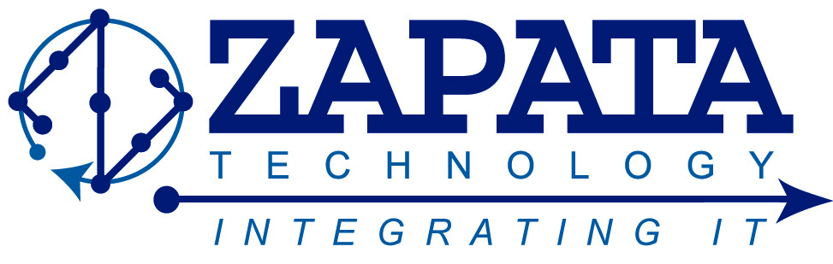
FOR IMMEDIATE RELEASE:
ZAPATA TECHNOLOGY, INC. MAKES WASHINGTON TECHNOLOGY’S FAST 50 SPECIAL REPORT
Augusta, GA, June 25, 2014 – Zapata Technology, Inc. (ZAPATA) is pleased to announce recognition by Washington Technology on its Fast 50 Special Report, which highlights the fifty fastest growing small companies in the government contractor market. The report will be published in the August issue of FCW magazine as well as on WashingtonTechnology.com, GCN.com, FCW.com, and DefenseSystems.com. Zapata has experienced 413% growth over the past three years and looks forward to continuing growth.
Founded in 2007, Zapata Technology is a HUBZone certified, veteran-owned, and self-certified Small Disadvantaged Business (SDB) IT consulting company. Our incredible team promotes and aggressively facilitates the cost effective integration of technology (products and specialized services) to enhance organizational performance in the areas of emerging technologies, information technology, and intelligence and cyber solutions. Our employees are dedicated, ethical, hold the latest industry technical certifications and credentials, and maintain active Security Clearances.
At Zapata Technology, we realize that our contributions are critical to helping our customers and teammates successfully meet their critical goals and mission objectives. Whether conducting business in the United States or overseas, Zapata Technology is the strategic partner of choice.

Media Inquiries:
Brad Powell
888-708-9840 Ext. 270
BradPowell@ZapataTechnology.com
www.ZapataTechnology.com
###

